**W3 mini assignment**

Student ID: 490111165 Student name: Jialu He

**1. Experience**

|  |  |  |  |
| --- | --- | --- | --- |
| **Time** | **Action** | **Good？** | **Comments** |
| 13:55 | Aug-16 start | Yes | I downloaded the book before. |
| 14:00 | Open a new word file to make some notes when I read the book. | Yes | Copy some important content into notes, using different signs and front size |
| 14:03 | Read the book until UX measure (Page) | No | Confusing about the structure of this section |
| 15:40 | Took a break |  |  |
| 16:00 | Draw a mind mapping | Yes | The mind mapping only list the headline of each part, but it is much clearer than before |
| 17:00 | Finish the reading until “Selecting benchmark tasks” (Page) | Yes |  |
| 10:00 | Aug-17 restart | Yes | See the map and consider the structure and homework concepts |
| 10:40 | Finish the review | Yes |  |
| 11:00 | Check the mail | Yes | See others comments on ED but don’t have useful message. |
| 14:00 | Aug-18 restart | No | The book is out of date. I need to find other way to read it. Check canvas and mail |
| 14:10 | Restart | Yes | Using map to check the process of reading the book |
| 15:00 | Finished all contents required and Took a break | Yes |  |
| 15:10 | Checked the meaning of homework concept and drew the C-map. | No | Confusing with some structure but fixed them eventually. |
| 16:00 | Finish homework. | yes |  |

**2.Cmap**

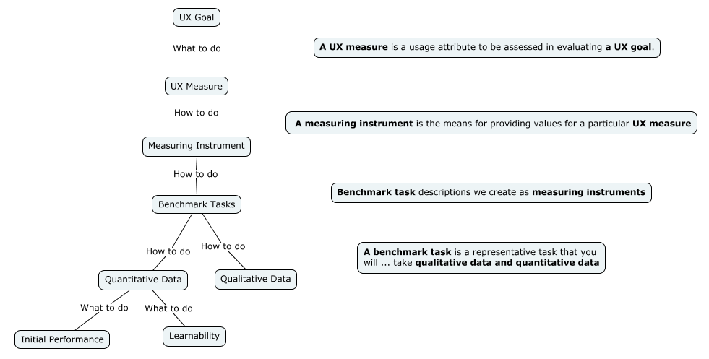

**3.Structure**

